Ottawa Home Economics Association – Amazing Hat production in 2023

Hats, hats and more hats.
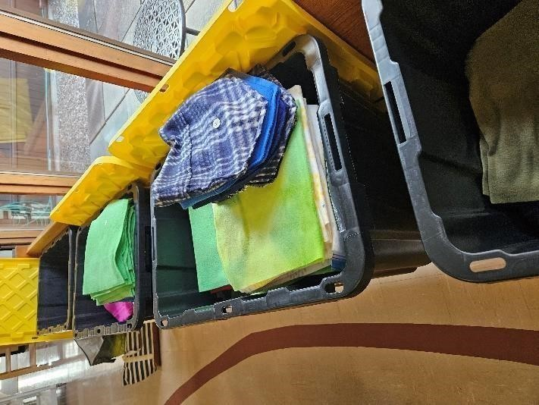
We have been sewing hats every fall for more than 20 years – thousands of them in total. This year, preparations for Hat Day were more challenging than in previous years. We expected that we would see increased demand from our traditional Hat Day community clients given the increased economic pressures being exerted on their clientele…this proved to be true. However, based on our current resources and production, it seemed unlikely that we would be able to fulfil all client requests this year. Our proposed strategy…
- to focus on the needs of smaller community-based groups such as those targeting women and children, and schools and food cupboards in lower-income communities or with special needs (groups with greater funding resources would receive any residual production); and
- to broaden our resources by seeking out additional sources of polar fleece fabric/funding and available volunteers in the community with sewing and related skills.

After the 2022 record production of 845 hats, our supply of polar fleece was exhausted. At the same time, donations of polar fleece were virtually non-existent and the amount and quality of polar fleece available locally was low and the price high. As a result, our purchases from the US increased -- good quality, lower-priced polar fleece could be purchased duty-free and delivered to us free of charge. Our Association provided $612.00, enough to make about 550 hats. But other funding sources needed to be found.

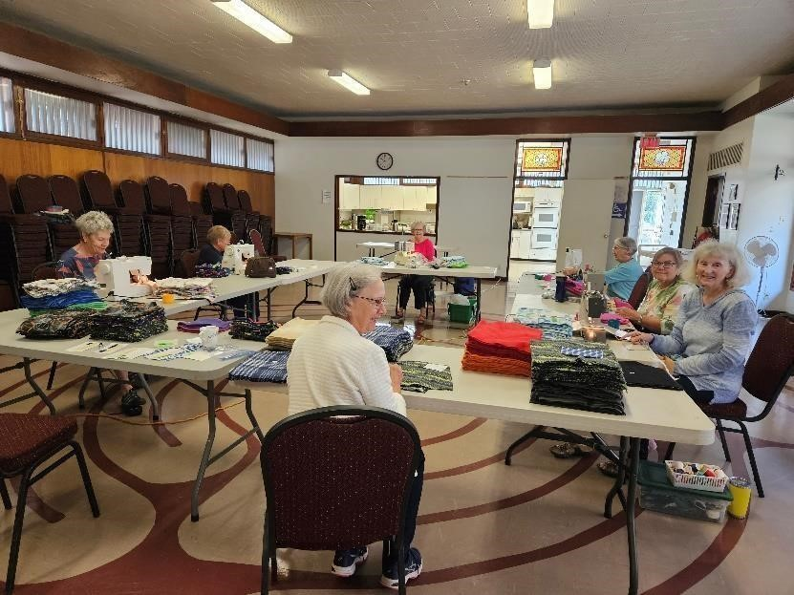
In preparation for Hat Day, a small but efficient group of Ottawa Home Economic Association member volunteers including Luba Brown, Elizabeth Lee, Linda Robbins, Cathy Enright, and Ellie Topp took on the task of cutting the polar fleece into four sizes of hats (child small, child medium, child large/adult small and adult medium) with male, female, and gender-neutral choices for each size. For the first time post-COVID, cut hats were brought to Bell’s Corners United Church, our historic production facility, on Tuesday, September 26 where a team of pinners, sewers, and sorters awaited. This year’s Hat Day volunteers included Carol Badenoch, Luba Brown,
Elizabeth Lee, Judy Leeson, Linda Robbins, Lynn Stewart, Susan Thorne, and Ellie Topp. At the end of the day, there were still hats that needed sewing, and additional sorting for distribution needed to be done so volunteers finished these tasks at home.

While production was taking place, NutritionBlocs (Abhijit Potdar, Founder), offered us a $400.00 donation towards purchase of additional polar fleece for 2023. Smaller amounts of fleece also came from May Chow and EcoEquitable.
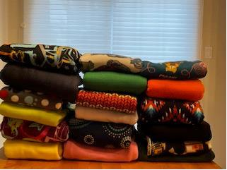
This was enough to produce an additional 309 hats (77 size 1 (child small), 90 size 2 (child medium), 104 size 3 (child large/adult small), and 38 size 4 (adult medium) hats), bringing us much closer to meeting client demands. A small group of volunteers including Susan Thorne, Ellie Topp, Cathy Enright, Lynn Stewart and Linda Robbins (aided by several enthusiastic community volunteers – Lisa, Melanie, and Christina) took on the task of cutting, sewing, sorting, and/or distributing the new hats. So, despite the challenges in 2023, our final Hat Day production reached 859 hats (up 14 hats from last year) and was delivered to an extremely grateful community in early November.

Socks!
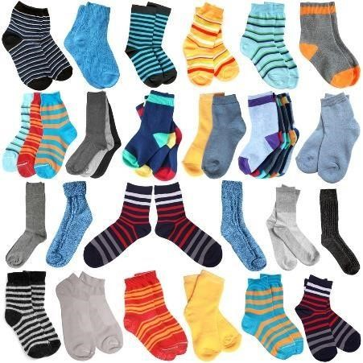
Our community outreach in 2023 also led us to a new opportunity for our clients – socks, a much-needed commodity. Mr. Rajesh Gawas, Founder & President of Gawas International Inc., a global manufacturer of socks with head office in Ottawa, learned of our activities to provide winter hats to Ottawa’s needy and offered a generous donation of 1300 pairs of new socks for distribution to our clients. The socks were very well received as they filled a much-needed clothing gap, especially during the winter months.

Despite our initial concerns, 2023 proved to be another extremely positive year for Hat Day and the Ottawa Home Economics Association. We found new visibility in the community, new approaches and opportunities for funding, stronger linkages and opportunities with historic clients/partners such as EcoEquitable, and new sources of volunteers in our community.

Linda Robbins, P.H.Ec. Coordinator, Hat Day 2023

